Package: EpiDynamics
Type: Package
Title: Dynamic Models in Epidemiology
Depends: R (>= 3.0.2)
Imports: deSolve, reshape2, ggplot2, grid
Description: Mathematical models of infectious diseases in humans and animals.
Both, deterministic and stochastic models can be simulated and plotted.
License: GPL (>= 2)

code/speed/algorithms/Gillespie or not

1. CODE
- Utiliser le booquin de Keeling2008 pour faire des codes.
- Utiliser seulement le code R
- Il y a deux répertoires (R et man).
- Ne peux pas lancer l'instruction “demo”.
- Le but du package est d'exécuter les modèles mathématiques des maladies infectieuses dans des animaux et de l'humain. Pour les deux, les mdèles déterministic et stochastic peuvent etre simulé et plotté.
## plotmode
# Parameters and initial conditions.  parameters <- list(beta0=17/13, beta1=0.1, gamma=1/13, omega=2*pi/365, mu=1/(50 * 365))  initials <- c(S=1/17, I=1e-4, R=1-1/17-1e-4)  # Solve the system.  #60 years  sir.sinusoidal.forcing <- SIRSinusoidalForcing(pars = parameters,init = initials,time = 0:(60 * 365))  PlotMods(sir.sinusoidal.forcing) | 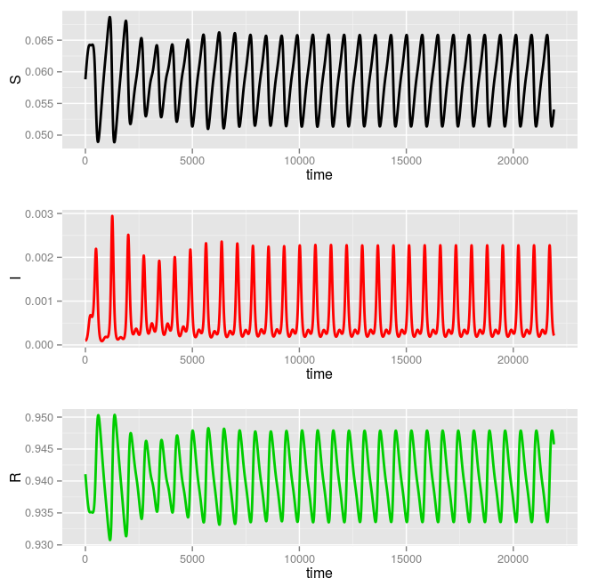

### SEIR modèle : Solves a SEIR model with equal births ans deaths
All parameters must be positive and S + E + I + R <= 1.
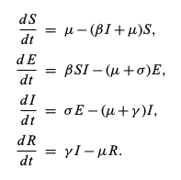

##SEIR model  # Parameters and initial conditions.  parameters <- c(mu = 1/(70 * 365), beta=520/365, sigma=1/14, gamma=1/7)  initials <- c(S = 0.1, E = 1e-04, I = 1e-04, R = 1 - 0.1 - 1e-4 - 1e-4)  # Solve and plot.  seir <- SEIR(pars = parameters, init = initials, time = 0:(60 * 365))  PlotMods(seir) | 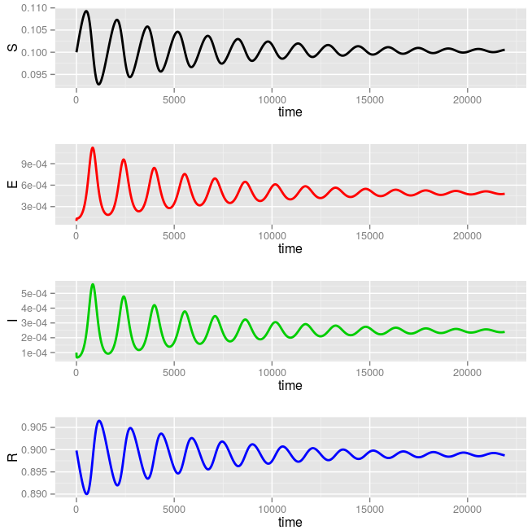  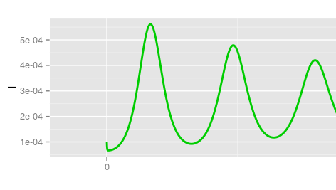 | - C'est les résultats pour le modèle SEIR deterministic pendant 60 ans  user system elapsed  1.295 0.002 1.299
###Modèle GIANG  system.time((seir(S=0.1,E=1e-04,I=1e-04,R=1-0.1-1e-4-1e-4,N=1,duration=60*365,mu=1/(70*365),beta0=520/365,beta1=0,sigma=1/14,gamma=1/7,type="deter"))) | 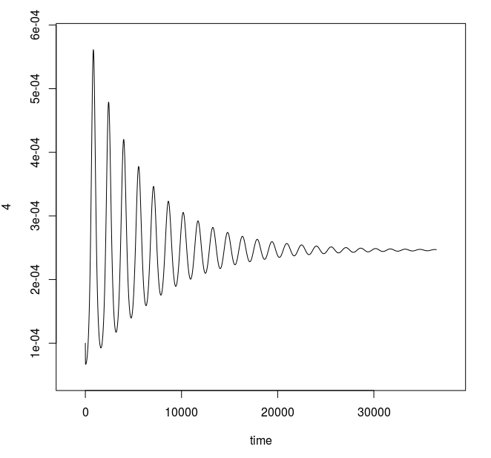 | user system elapsed  0.029 0.000 0.029

### SEIR4AgeClasses
Résoudre un modèle SEIR avec quart groupes d'âge différentes et avec des mouvements annuels entre les goupes imitant l'année scolaire.
#pars : a matrix with the transmission rates, the rate at which individuals
move from the exposed to the infectious classes, the recovery rate, a vector with
death rates in each age group, and a vector with birth rates into the childhood
class. The names of these elements must be "beta", "sigma", "gamma", "mu",
and "nu", respectively, see example.
#init : vector with 16 values: initial proportions of the population that are susceptible,
exposed, infectious and recovered in a particular age group. The vector must be
named, see example. Requirements: S + E + I <= n for each age group and all
values must be positive.
#time : time sequence for which output is wanted; the first value of times must be the
initial time.

###SEIR4AgeClasses  # Parameters and initial conditions.  parameters <- list(beta = matrix(  c(2.089, 2.089, 2.086, 2.037,  2.089, 9.336, 2.086, 2.037,  2.086, 2.086, 2.086, 2.037,  2.037, 2.037, 2.037,2.037),  nrow = 4, ncol = 4),  sigma = 0.125, gamma = 0.2,  mu = c(0, 0, 0, 1) / (55 * 365),  nu = c(1 / (55 * 365), 0, 0, 0),  n = c(6, 4, 10, 55) / 75)  initials <- c(S=c(0.05, 0.01, 0.01, 0.008),  E=c(0.0001, 0.0001, 0.0001, 0.0001),  I=c(0.0001, 0.0001, 0.0001, 0.0001),  R=c(0.0298, 0.04313333, 0.12313333, 0.72513333))  #Solve and plot.  #Uncomment the following lines (running it  seir4.age.classes <- SEIR4AgeClasses(pars= parameters,  init= initials,  time= 0:36500)  PlotMods(seir4.age.classes,variables = c('I1' , 'I2' , 'I3', 'I4'), grid=F)  ### | 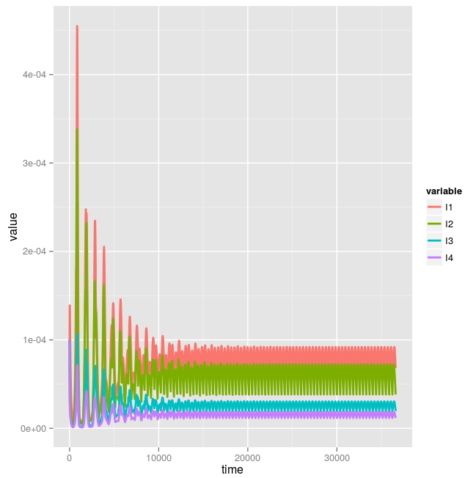 | - très lent

##Modèle SIR
###SIR  # Parameters and initial conditions.  parameters <- c(beta = 1.4247, gamma = 0.14286)  initials <- c(S = 0.8, I = 1e-06, R = 1 - 0.8 - 1e-06)  # Solve and plot.  sir <- SIR(pars = parameters, init = initials, time = 0:70)  PlotMods(sir) | 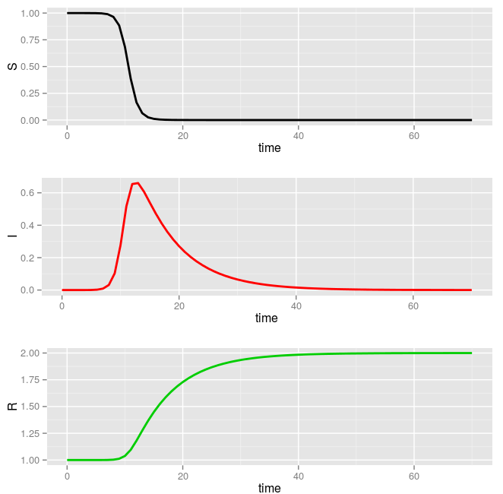 | system.time(sir <- SIR(pars = parameters, init = initials, time = 0:70))  user system elapsed  0.012 0.000 0.011
###Modèle GIANG  system.time((a<-seir(S=0.8,E=0,I=1e-06,R=1-0.8-1e-6,N=1,duration=70,mu=1/(70*365),beta0=1.4247,beta1=0,  sigma=Inf,gamma=0.14286,type="deter")))  plot(a) | 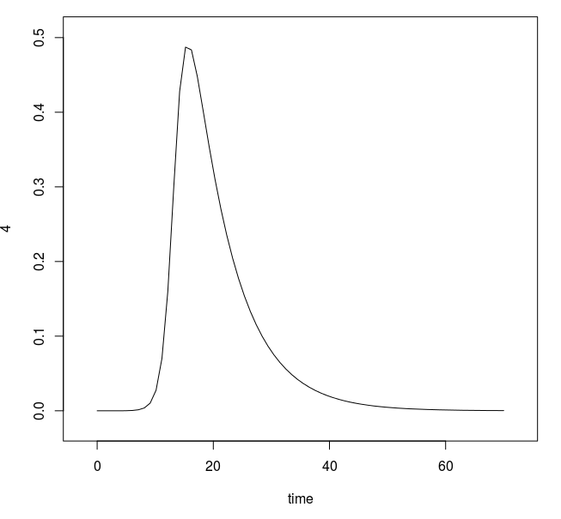 | user system elapsed  0.003 0.000 0.003

## natalité/mortalité  # Parameters and initial conditions.  parameters <- c(mu = 1/(70 * 365),  beta = 520/365, gamma = 1/7)  initials <- c(S=0.1, I=1e-4, R=1 - 0.1 - 1e-4)  # Solve and plot.  sir.birth.death <- SIRBirthDeath(pars = parameters, init = initials,time = 0:(60 * 365))  PlotMods(sir.birth.death) | 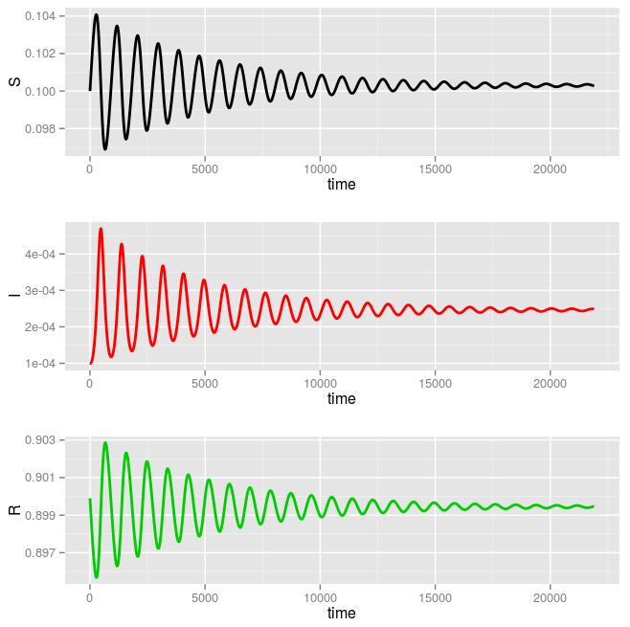 | system.time(sir.birth.death <- SIRBirthDeath(pars = parameters, init = initials,time = 0:(60 * 365)))  user system elapsed  1.131 0.001 1.133
> system.time((a<-seir(S=0.1,E=0,I=1e-04,R=1-0.1-1e-4,N=1,duration=60*365,mu=1/(70*365),beta0=520/365,beta1=0,sigma=Inf,gamma=1/7,type="deter")))  > plot(a) | 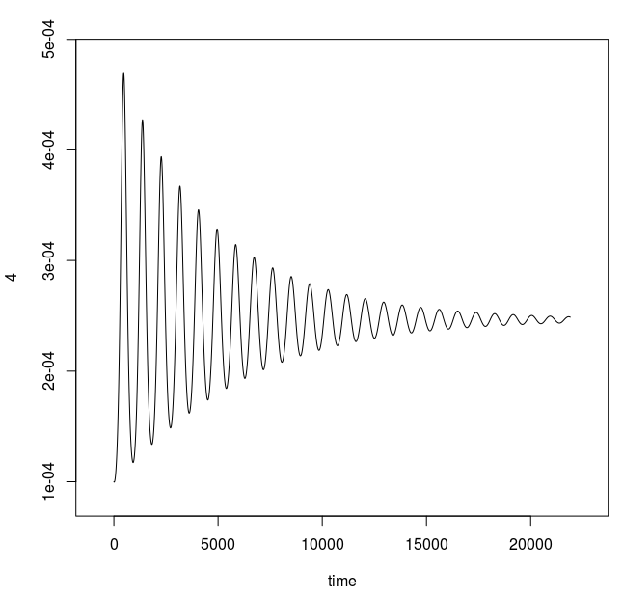 | user system elapsed  0.028 0.000 0.029

##SIR stochastic Gillespie

# Parameters and initial conditions.  parameters <- c(beta = 1, gamma = 1 / 10, mu = 5e-4)  initials <- c(X = 500, Y = 25, N = 5e3)  # Solve and plot.  system.time(sir.demog.stoch <- SIRDemogStoch(pars = parameters,init = initials, time = 2 * 365))  PlotMods(sir.demog.stoch) | 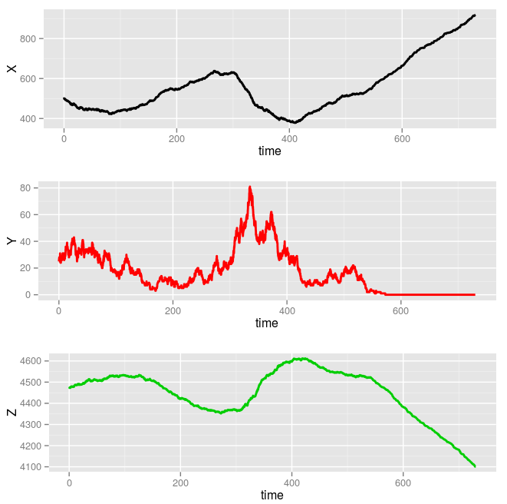 | user system elapsed  4.982 0.049 5.036
system.time((a<-seir(S=500,E=0,I=25,R=5e3-500-25,N=5e3,duration=2*365,mu=5e-4,beta0=1,beta1=0,sigma=Inf,gamma=1/10,type="sto")))  S.S E.E I.I R.R  500 0 25 4475  0 500 0 25 4475 5000  > plot(a) | 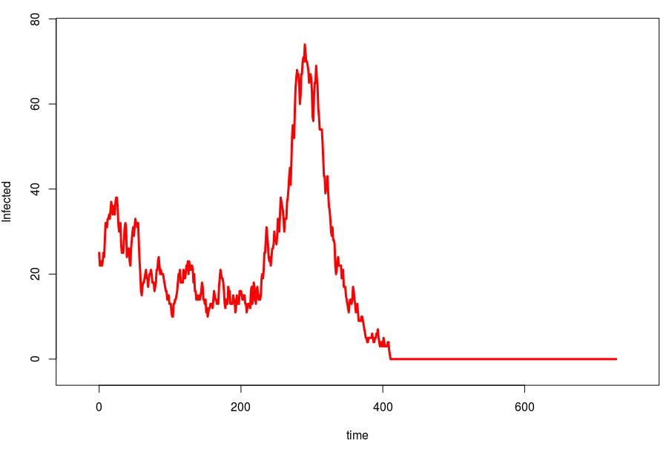 | user system elapsed  0.004 0.000 0.005

2. SPEED
- plus lent que le parkages de GIANG
3. ALGORITHMS
- Utiliser des équations différentielles (ode) pour les modèles SIR/SEIR
- faire attention au structure d'âge/transporteur
- exploiter trois modèles principaux SIR/SIS/SEIR
- modèles déterministic/stochastic/sinusoidal/tauleap
- ajouter un bruit pour les taux de transmission.
4. Gillespie/ or not
- Les memes résulats quand on lance les meme valeurs de paramètres et varaiables.

